Date | 03 October 2026
Team ID | SWTID-2026-7735
Project Name | Auto Ticket Classification using Flow Designer
Maximum Marks | 2 Marks

Project Design Phase
Problem – Solution Fit Template
Problem – Solution Fit Template:
The Problem-Solution Fit ensures that the solution realized in Flow Designer genuinely solves the school helpdesk's triage bottlenecks.
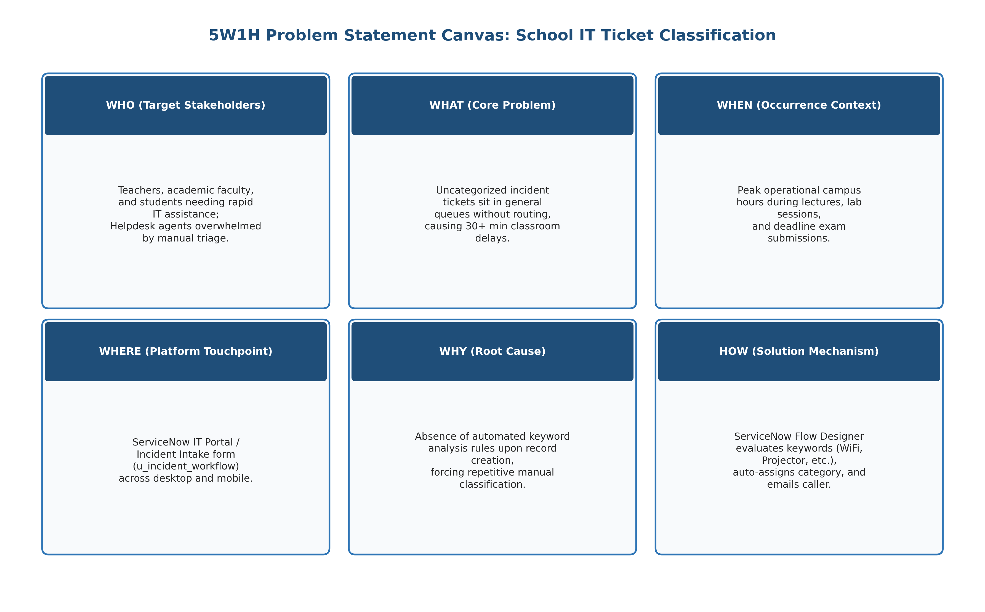
Figure 3.1: Problem-Solution Fit Matrix & 5W1H Alignment Canvas
Canvas Building Block | Analysis for Auto Ticket Classification in ServiceNow
1. Target Customer Segment | Primary: School teachers, professors, and students across academic campuses.  Secondary: School IT helpdesk administrators, technical coordinators, and department heads.
2. Critical Customer Problems | • Uncategorized Tickets: Tickets enter general pools without category, delaying technician assignment.  • Classroom Disruption: Projector or Wi-Fi failures stall lectures while waiting for manual triage.  • Administrative Burden: IT agents spend 25-35% of working hours manually reading and classifying tickets.  • Lack of Acknowledgment: Callers receive no immediate confirmation that their ticket was recorded.
3. Existing Alternatives & Flaws | • Manual Helpdesk Triage: Slow, prone to human error, and completely bottlenecks during morning peak periods.  • Complex Form Dropdowns: Forcing non-technical teachers to navigate 30+ IT categories leads to misclassification.  • Phone Calls & Walk-ins: Highly interruptive, unorganized, and leaves zero audit trail.
4. Proposed Solution & Features | • No-Code Flow Designer Automation: Evaluates keywords ('Wi-Fi', 'Projector', 'Password', 'Slow Computer') in Short Description.  • Custom Isolated Table: 'Incident WorkFlow' (u_incident_workflow) with Auto-Numbering (INC prefix).  • Dependent Choice Architecture: Subcategory choices dynamically filter based on assigned Category.  • Instant Automated Email: Sends personalized confirmation to caller immediately upon classification.
5. Unique Value Proposition (UVP) | Zero-touch, real-time ticket categorization and immediate caller acknowledgment delivered through 100% native no-code ServiceNow Flow Designer.
6. Channels of Engagement | ServiceNow Self-Service Portal, Form Designer UI, Classroom Desktop Bookmarks, and automated email notifications.
7. Key Performance Indicators (KPIs) | • 100% automated classification accuracy for defined keyword incidents.  • Reduction in ticket categorization turnaround from 35+ minutes to under 2 seconds.  • 100% automated email notification delivery to callers.  • 30% reduction in manual helpdesk administrative hours.
8. Unfair Advantage & Sustainability | Built entirely on ServiceNow standard platform capabilities without external paid APIs or custom scripting, ensuring seamless upgrades.

